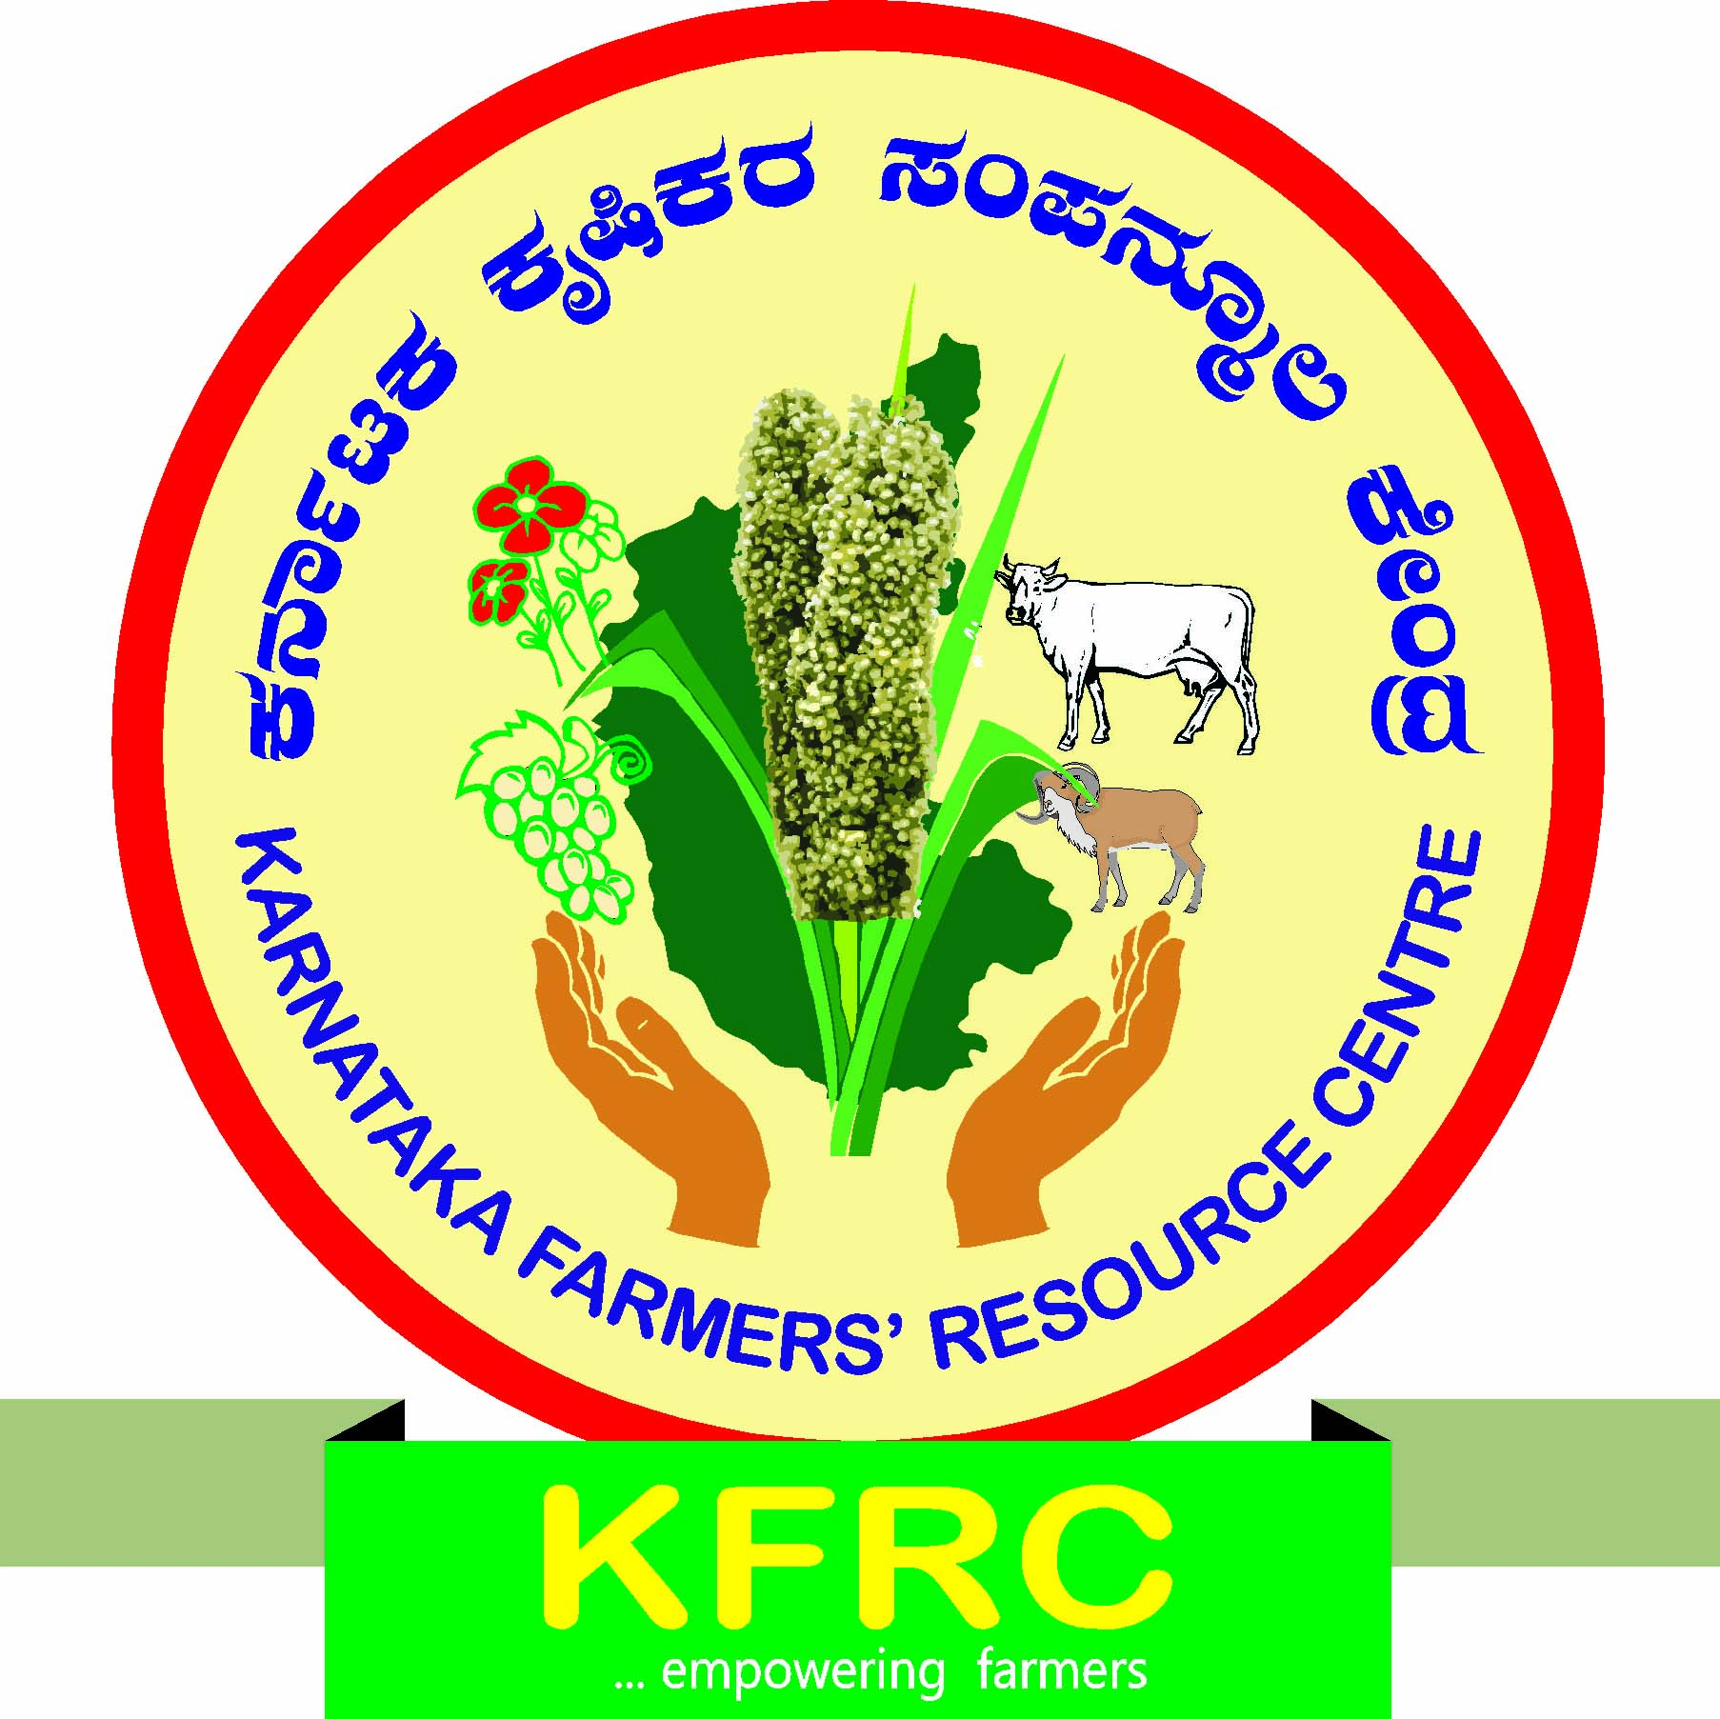
KARNATAKA FARMERS’ RESOURCE CENTRE: BAGALKOT.
B.V.V.Sangha’s Spinning Mill Complex, Gaddanakeri Road, BAGALKOT-587102.
Phone No. 08354-244028 / 244048, Tele Fax-08354-244028, Mobile: 9449862194(ED)
E-mail: kfrcbagalkot@gmail.com
“CHARITABLE TRUST” www.kfrc.org

Progress under Annual Action Plan for 2016-17

Events | FOR THE YEAR 2016-17 |  |  |  | PROGRESS  SINCE INCEPTION
 | ANNUAL PLAN |  | ACHIEVEMENT  Up to 31.03.2017
 | No. of Prog | Partici  pants | No. of Prog | Partici  pants | No. of Prog | Partici  pants
- Awareness  programmes | 36 | 3600 | 26 | 2731 | 208 | 25507
- Core  programmes | 75 | 2625 | 50 | 1705 | 396 | 15236
Grand Total | 111 | 6225 | 76 | 4436 | 604 | 40743
% of Achievement over Target | -- | -- | 68% | 71% | -- | --

